MCI - Lab 01
Muhammad Mughees Siddiqui 10047
Hamza Sami 09934

Code Snippet:
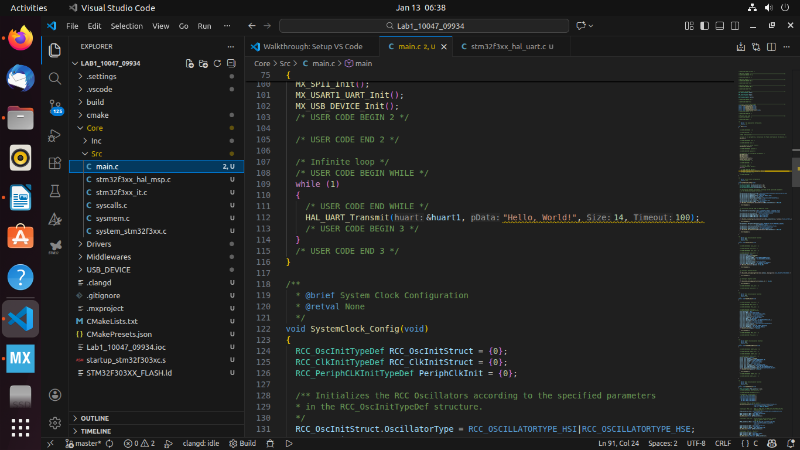

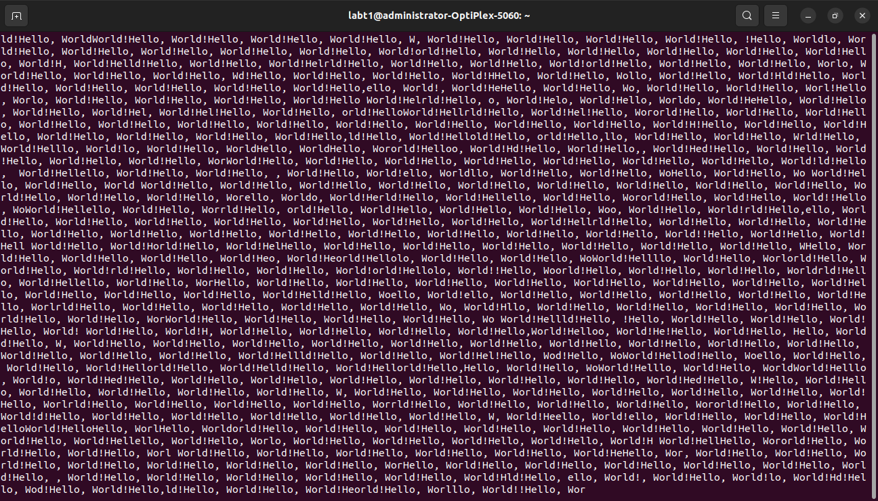
Terminal Snippet:

a) In the Hello World task, why is HAL UART Transmit() placed inside the while(1) loop, and what could go wrong if it’s placed outside?
Answer: It is placed inside the while loop because to allow for continuous transmission of data while the program is running. If it was placed outside then the message would only be sent once and no further data will be transmitted. If we don’t do this and place it outside it might look like the UART has stopped working.

(b) You used the command screen /dev/ttyACM0 115200 in this lab. What is the purpose of this command, and what would happen if the baud rate specified does not match the one configured in STM32CubeMX?
Answer: The purpose of this command screen is to open a serial terminal connected to the STM32 board so that it can transmit and display the data over UART. If the baud rate in the command does not match the baud rate configured in STM32CubeMX then the serial communication will fail as the transmitter and receiver will not be synchronized over the same baud rate.

